NAVJEEVAN KISAN (P.G.) COLLEGE, MAWANA (MEERUT)

Dear Sir,

Here are your required details:

1. Logo:

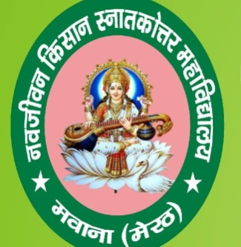

1. Email: [**njkdcollege@gmail.com**](mailto:njkdcollege@gmail.com)
2. Call Number: **9412885763, 9761391314**
3. 5 Images of College:

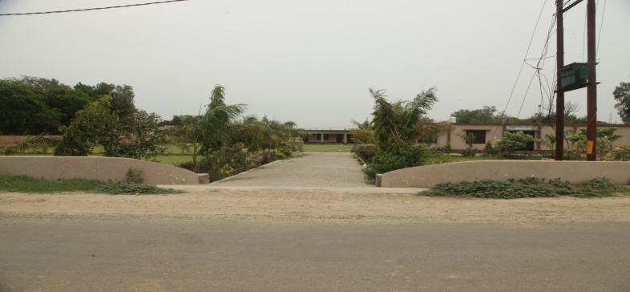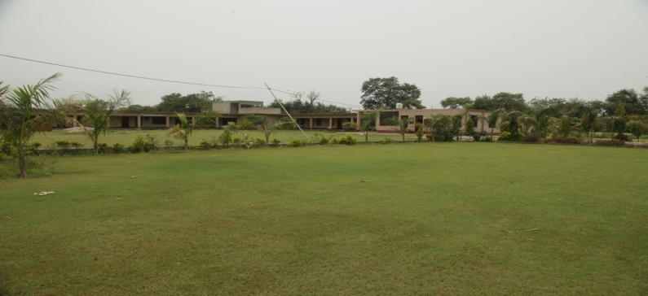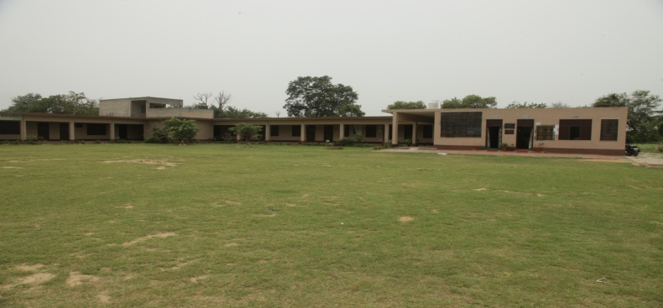–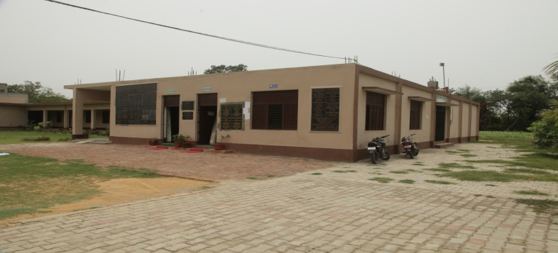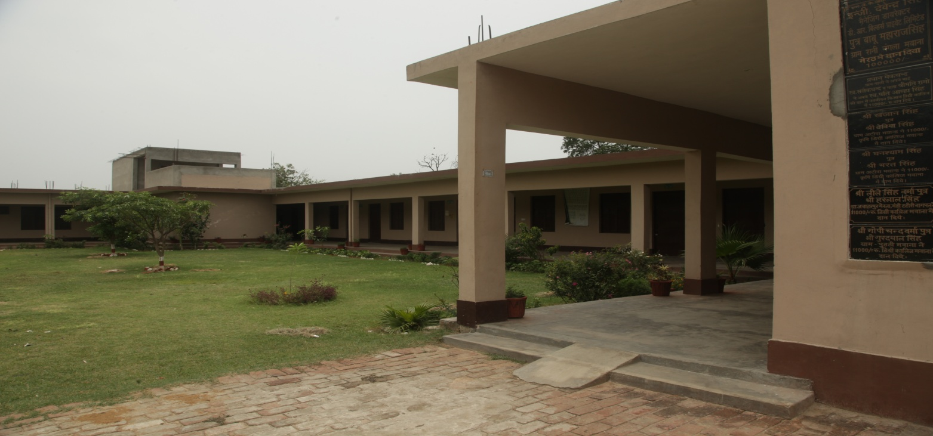

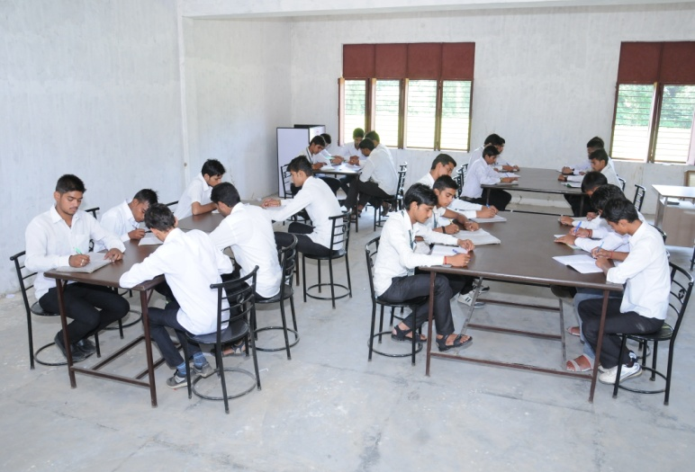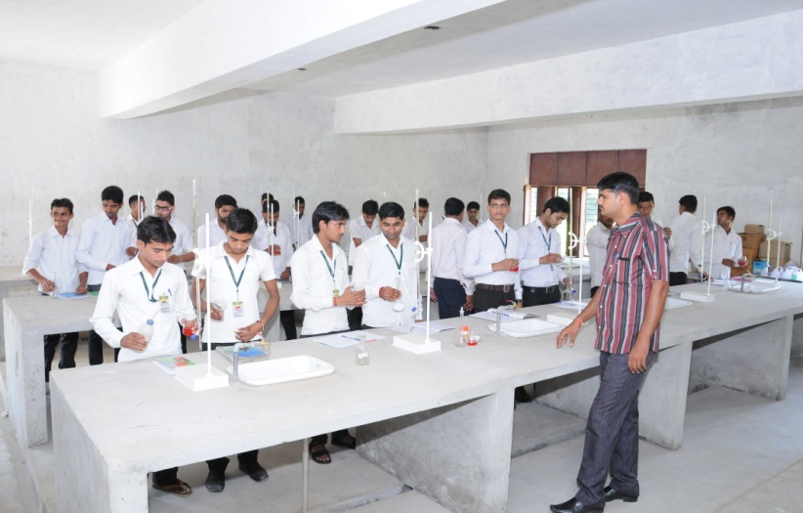

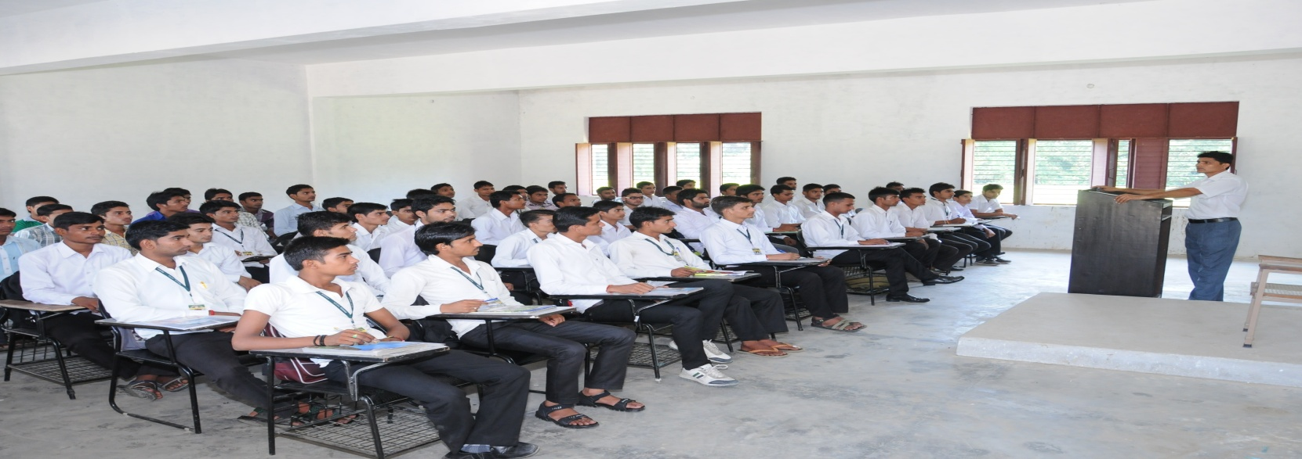

1. Full Name of College: **NAVJEEVAN KISAN (P.G.) COLLEGE**
2. Address of College: **Makhdumpur Road, Near Gang Nahar, Mawana, Distt. Meerut (U.P.)-250401**
3. Features of College:
4. Management College
5. **1350** Students are enrolled
6. Practical Experience Opportunities
7. Certified/Approved teachers
8. Books & Library
9. Sports Facilities (Both Indoor & Outdoor)
10. Situated in Mawana Rural Area (500 Meters apart from Noisy City)
11. WiFi Campus
12. Graduation Course- B.A. & B.Sc. Agriculture

Post Graduation Course- M.Sc. Ag.-Horticulture

1. Hostel Facility for economically weak students (Free of Cost)
2. Very low cost of tuition fees
3. Transport Facilities
4. N.S.S.
5. Well equipped laboratories & Smart Classrooms
6. Excellent Academic Result
7. Healthy Academic Environment
8. Computerization of Library & Administration
9. Smart Conference hall
10. Strong Alumni Association
11. Ragging is Strictly Prohibited
12. Anti Ragging & Anti sexual harassment committee
13. Parent Teacher Meets
14. College is under surveillance of C.C.T.V.
15. Specious hall for indoor games
16. Beyond Government scholarships college gives financial assistance
17. Services offered by college:
18. Career Counseling
19. Campus healthcare
20. Organizing Seminars
21. Student counselors
22. Regular classes
23. Academic & Financial Aid Counseling
24. Visits of SAU’s/KVK etc.
25. Cultural & Social Activities
26. Academic & Personal development
27. Digital Library & Study space
28. Disability Services
29. Absence evaluation
30. About Us of College:

Navjeevan Kisan (P.G.) College is situated in Mawana rural area in district Meerut in U.P. state of India, established in 2003. The college area is 7 hectares above. The college imparts education at the graduate and post graduate levels and has facilities of computerized library & office. There are fully time highly qualified faculty members and research scholars pursuing research work for the award. The College has 2(F) & 12(B) certificates issued from U.G.C., Delhi. NAAC Accreditation is under process.

1. Certified/University Approved Teachers:
2. **Faculty of PG Courses :M.Sc. Ag.-Horticulture**
3. Dr. Munendra Singh (Principal)

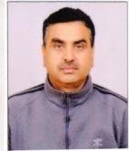

1. Dr. Arvind Kumar Chaudhary – Assistant Professor (Horticulture)

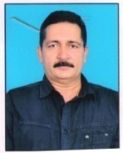

1. Dr. Manoj Kumar – Assistant Professor (Horticulture)

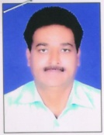

1. Dr. Shivanand Mishra – Assistant Professor (Horticulture)



1. **Faculty of UG Courses :B.Sc. Agriculture**
2. Sh. Arun Kumar – Assistant Professor (Agriculture Botany Department)

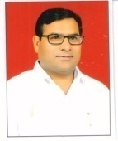

1. Dr. Amit Tyagi – Assistant Professor (Agriculture Chemistry-Soil Science)

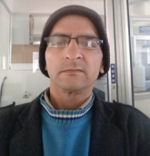

1. Dr. Kapil Kumar – Assistant Professor (Dairy Science & Technology)
2. Dr. Ravindra Kumar Sharma – Assistant Professor (Agronomy)

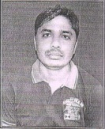

1. Dr. Virendra Kumar– Assistant Professor (Ag. Botany)

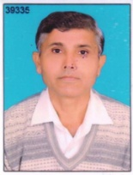

1. Mr. Atul Kumar Sharma– Assistant Professor (Agronomy)

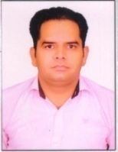

1. Mr. Sohan Veer– Assistant Professor (Ag. Extension)

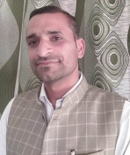

1. Mr. Vinit Kumar Sharma – Assistant Professor (Plant Pathology)

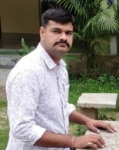

1. Mr. Amit Kumar– Assistant Professor (Entomology)

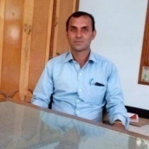

1. Mr. Krishan Kumar- Assistant Professor (Statistics & Computer Applications)
2. Mr. Sanjay Kumar- Assistant Professor (Horticulture)
3. **Faculty of UG Courses :Bachelor of Arts**
4. Dr. Naseemuddin (Head of Department of Arts) – Assistant Professor (Political Science)

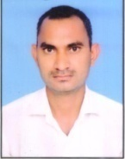

1. Dr. Anuradha – Assistant Professor (Sociology)

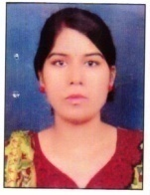

1. Mr. Atul Kumar – Assistant Professor (Economics)

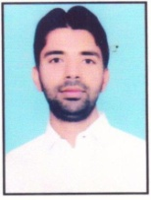

1. Dr. Manju Agarwal – Assistant Professor (Hindi)



1. **Office Staff/Non-Teaching Staff:**
2. Mr. Vijay Kumar (Head Clerk)

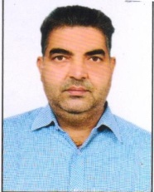

1. Mr. Krishan Kumar (Computer)

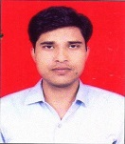

1. Mr. Sandeep Kumar (Librarian)

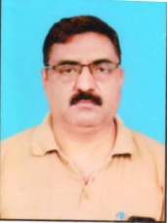

1. Mr. Anuj Chandel (Clerk)

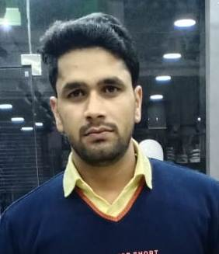

1. Mr. Ankur Kumar (Office Peon)

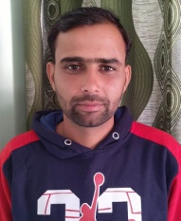

1. Mr. Kishan Pal (Sweeper)

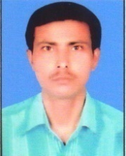

1. Mr. Mukesh Kumar (Gardener)

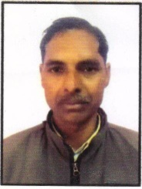

1. Mr. Pramod Sharma (Cook)

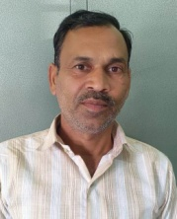

1. Number of Students: **798**
2. Number of Courses & Their Name with Short Description:
3. B.Sc. Agriculture – Permanent Affiliation from Chaudhary Charan Singh University, Meerut with total seats of 160.
4. M.Sc. Ag.-Horticulture – Affiliated from C.C.S. University Meerut in academic year 2017-18 with 30 seats.
5. Bachelor of Arts – Affiliated from C.C.S. University Meerut in academic year 2017-18 with total 140 seats in subjects Economics, English, Hindi, History, Political Science, Sanskrit, Sociology.
6. Testimonials of Students:

“I have studied more comfortably in this college because all teachers & staff are very friendly. I feel so proud of being the student of N.K. (P.G.) College. There are many teacher’s hard working behind my success. Thank you to all my teachers, principal sir and all staff including non-teaching staff for constant support and guidance.”

Prashant Sharma (JRF)

(Batch 2016-17)

“What I loved in this college was the quality education provided by experienced faculty. We are continuously motivated to do practicals and RAWE projects in all the four years of study. I am forever grateful to N.K. (P.G.) College.”

Riyasat Ali (Bhandora Organics)

(Batch 2014-15)

“At the very outlet, I would like to express my heartfelt thanks to N.K. (P.G.) College family. The friendly environment and the systematic approach in imparting education made me a competent individual.”

Anuj Kumar (Geneva Crop Science)

(Batch 2016-17)

1. Testimonials of Principal and Higher Authorities along with photos:

“The challenges of education have increased consid erably in recent times and we as administrations and teachers need to be better equipped to deal with these challenges. Our world is a global village where education plays a very crucial and wide role in every person’s life.”

1. Events Conducted by college with photos:

1. Conference - Organizations of seminars and conference from time to time for regular networking with the subject. 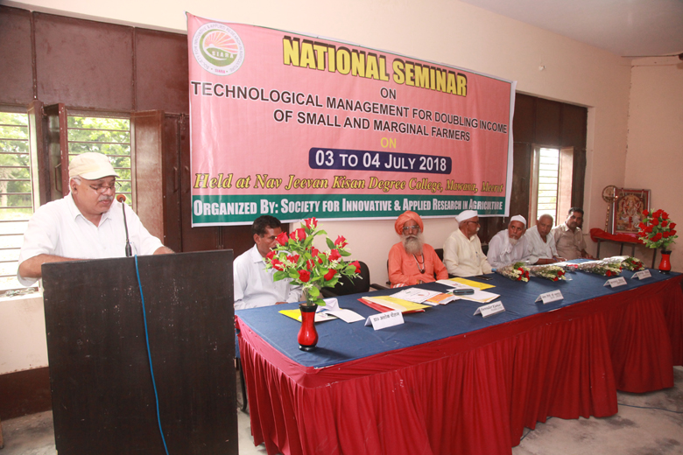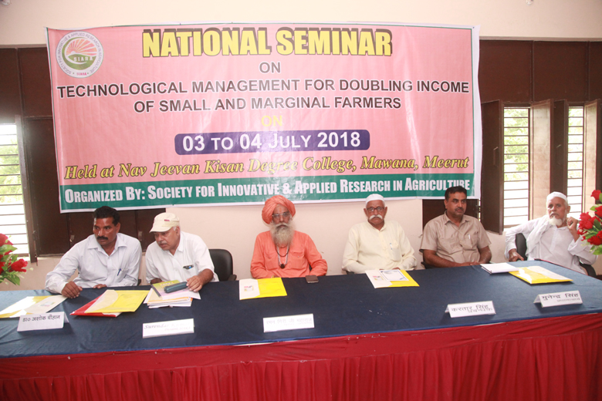

1. K.V.K. Visits

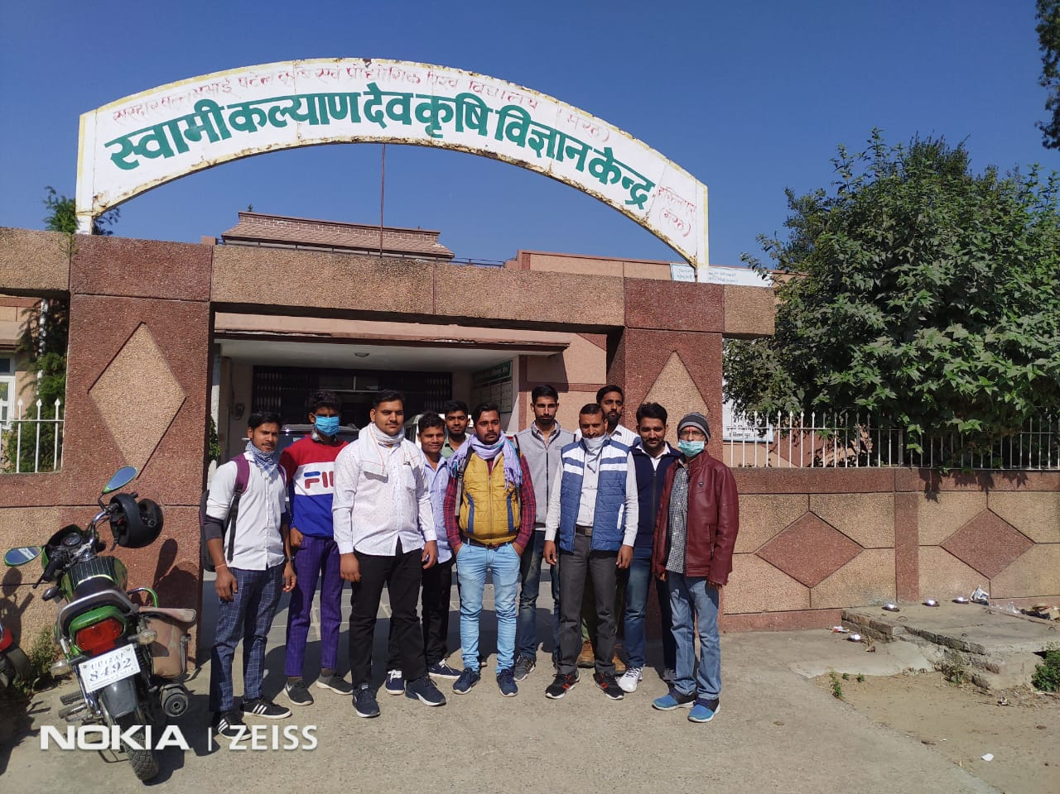

1. Kisan Mela Visits
2. Parent Teacher Meets
3. N.S.S.

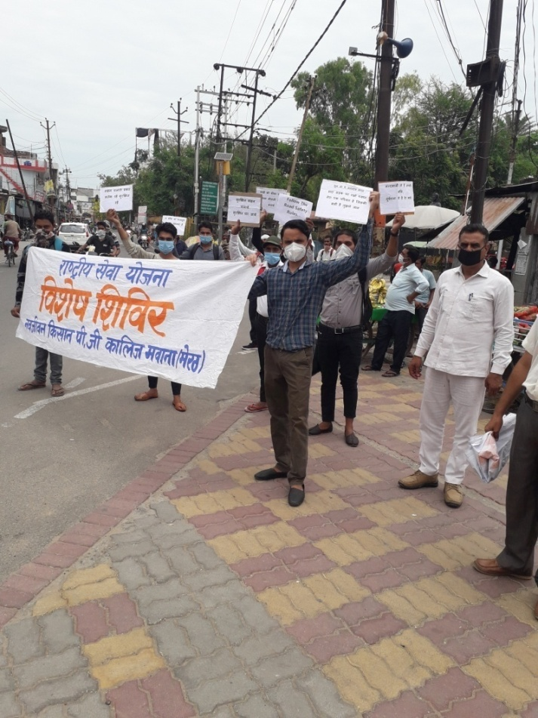

1. Cultural Programs – Celebration of Establishment day every year on 1st of March.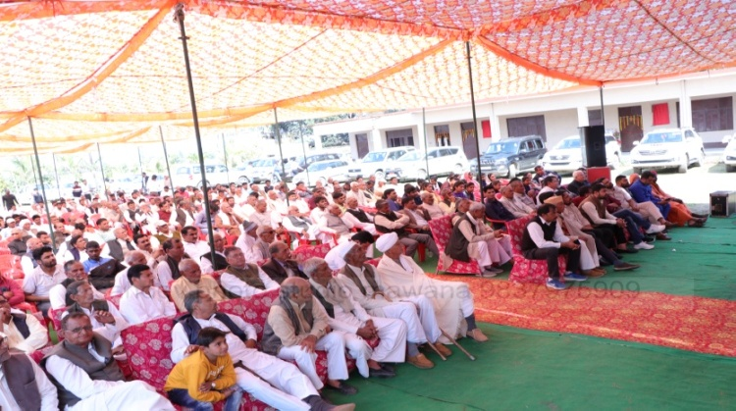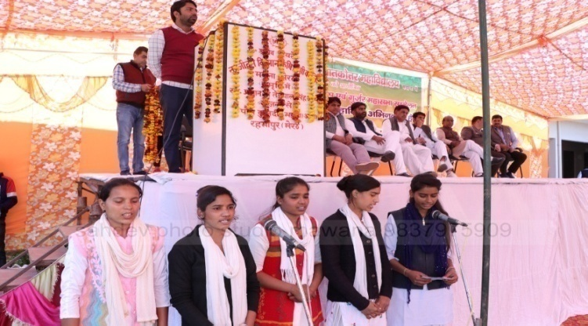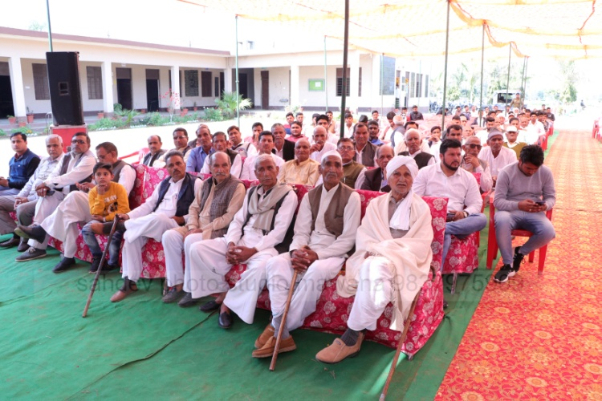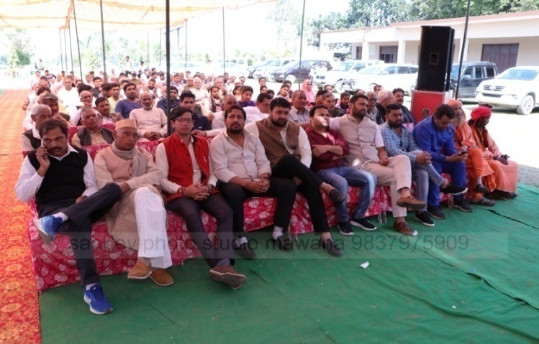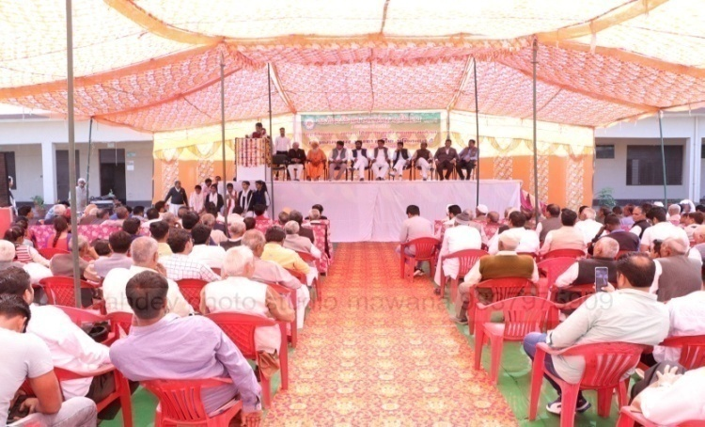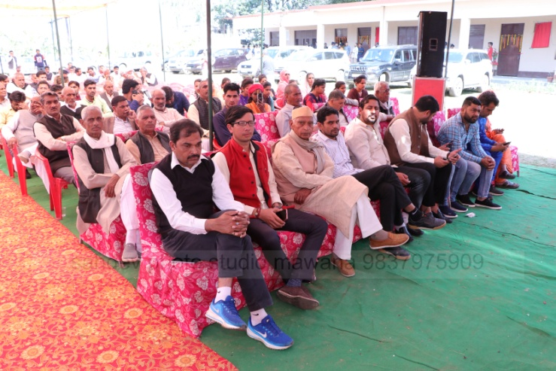
2. Awards:

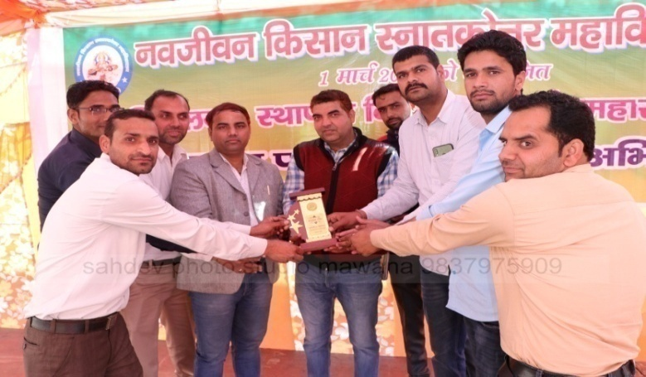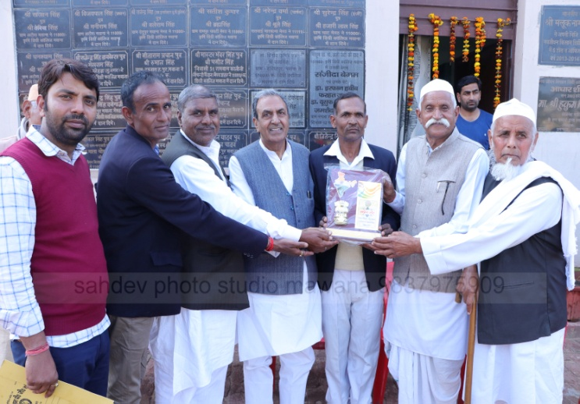

1. Awarding Students:

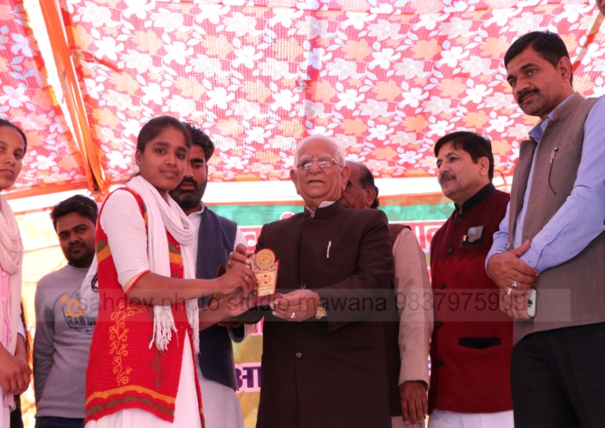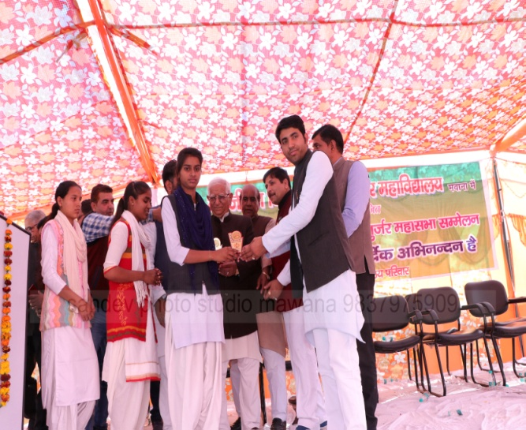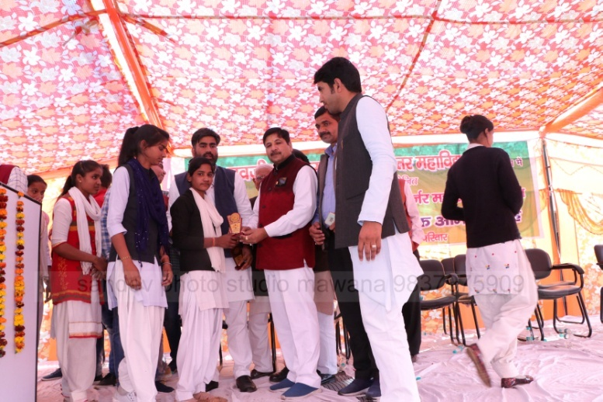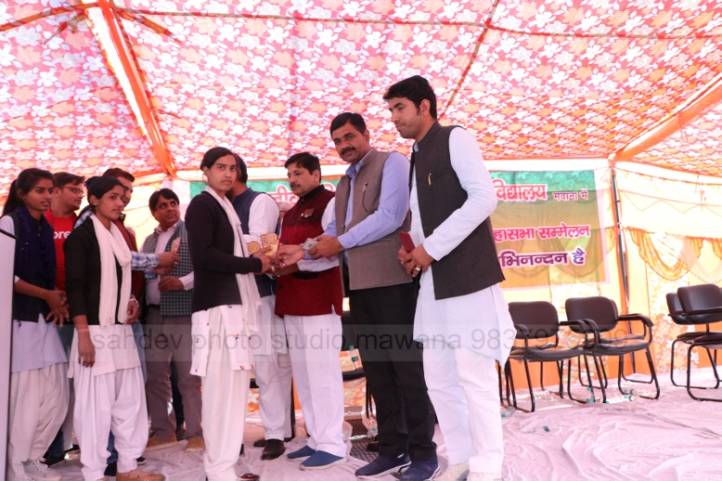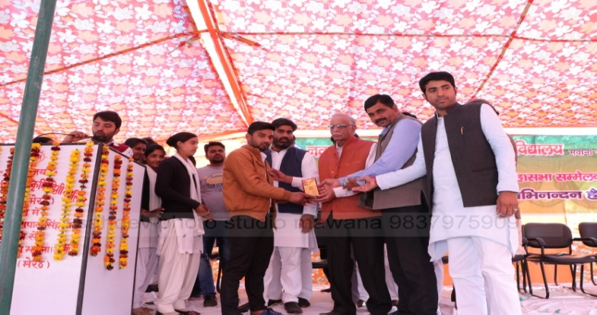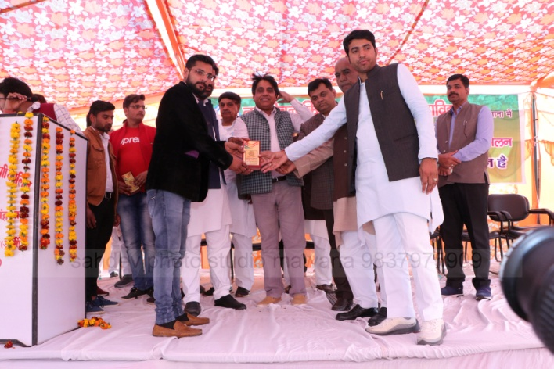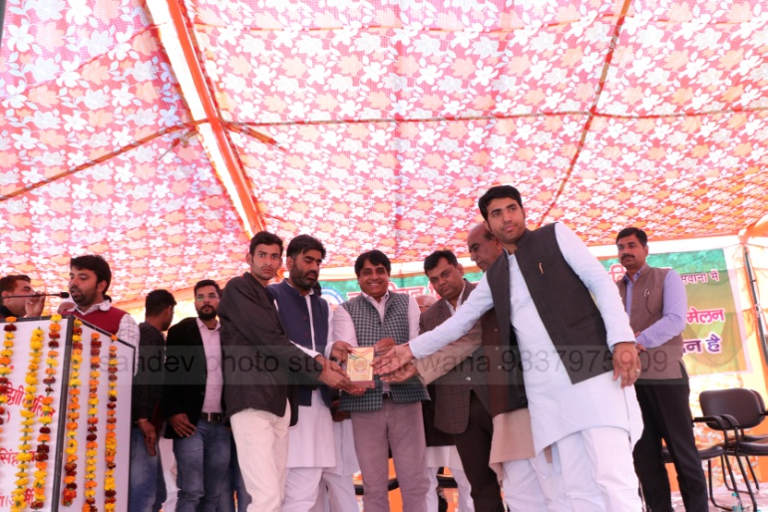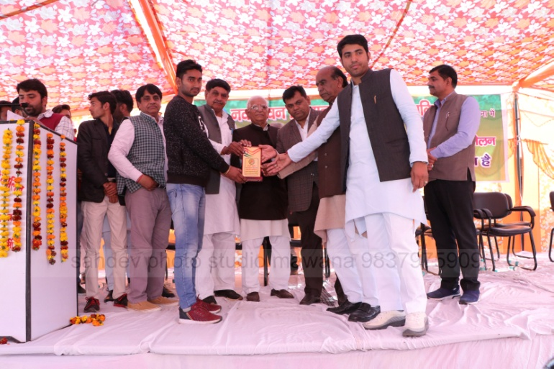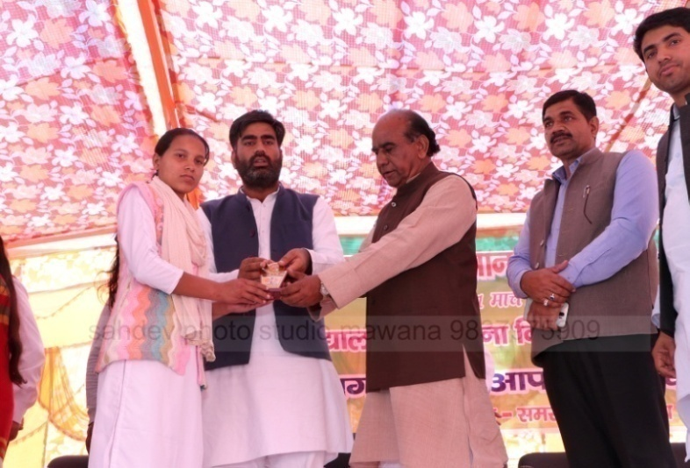

1. Number of Departments:
2. PG Level- Horticulture
3. UG Level- Agriculture
4. Agronomy
5. Horticulture
6. Ag. Botany
7. Ag. Chemistry
8. Dairy Science & Technology
9. Ag. Extension
10. Plant Pathology
11. UG Level- Art
12. Economics
13. English
14. Hindi
15. History
16. Political Science
17. Sanskrit
18. Sociology